Abstract:

Soft-body robots have always received less attention compared to other branches of robotics. However, this does not suggest that they are any less capable than traditional robots due to their extreme flexibility. Soft robots commercially can be used in medical situations and with human interaction. This includes deployment into a human’s body. However, the use case also extends into disaster relief situations. The flexibility of soft robots gives them an advantage over rigid robots when they are navigating through narrow spaces. Because of this flexibility, designing an optimized and sturdy system is difficult. In this paper, I proposed a

摘 要

简要的说明本文的背景、研究内容及成果（论文大体完成后写这块内容）

**关键词**：4-5个关键词

The goal of this study is to create a better version of the soft robotic snakes already developed. This can be divided into two parts: software, and hardware. The software part would include software on the robot, and software on the computer. The microcontroller on the robot would need to process images with Machine Learning and Vision to better identify the environment. The robot also identifies objects and obstacles around it and sends their positions along with the video from the camera and some other data such as humidity and temperature altogether back to the computer. The computer then constructs a 3D map of the area and outputs the video to the user. The user can also choose to control the robot manually and the computer would send these commands to the robot.

The goal for the hardware part of the robot is to implement a more efficient flexible structure that better utilizes the air pressure and moves more controllably. The structures previous soft robotic snakes utilize is requires high air pressure and the expansion is rather uncontrolled and unideal. The structure is also very complicated and the connection between the flexible and rigid parts is hard to work with, not to mention the difficulties with preventing leakage of air with those structures.

目 录

标题 I

摘 要 I

目 录 II

1 绪论 3

1.1 课题研究的背景及意义 3

1.2 国内外研究现状 3

2 理论设计 3

3 结构设计 3

4 硬件设计 3

5 运动模式（特点）/软件控制/程序设计 3

6 实验 4

7 总结与展望 4

参考文献 4

# 绪论

## 课题研究的背景及意义

Every second counts after a disaster yet rescue teams cannot always get to places needing the most help right away due to obstacles and often dangers. This could include collapsed buildings, flooded tunnels, ablaze rooms, etc. To shorten the time between the disaster providing aid, mere human isn’t enough. Specialized robots for different deadly environments are needed to support the rescue effort better.

Collapsed buildings can be seen anywhere after almost all types of disasters — earthquakes, hurricanes, tsunamis, etc. Clearing a path through tons of debris is both time-consuming and laborious. To explore this environment more efficiently and more easily, a much smaller robot, and much more suited for this situation is needed — a soft robotic snake. Bionic snakes are naturally perfect for slithering through tight gaps and small tubes that the rescuers would otherwise be unable to cross. This could drastically speed up the exploration of ruined areas and the time takes to get to the ones needing help. Although this cannot fully replace the purpose of human rescuers and the need to clear up the area to people, this can provide some emergent aid while the main rescue force is on its way.

## 国内外研究现状

This life-saving robot is of course not a completely new area of study. Many researchers have already attempted to recreate this fascinating animal. Wright and his team developed a simple modular robotic snake design using chained servos. Crespi and his team developed a more complicated robotic snake involving DC motors and detachable wheels to traverse both on the ground and in water. However, rigid bodies cannot fully mimic the movement of snakes as these robots can only move at the joints. Thus, many turned to softer and more flexible materials to achieve smoother turns. In a report presented at the International Conference of Soft Robotics (RoboSoft), Qin and his team used silicon tubes to achieve segments with 3 degrees of freedom (DoF). Each tube is responsible for 1 DoF and with three tubes, the soft robotic snake can perform locomotion much closer to that of a real snake than the rigid robotic snake. However, their design is much more complicated than the ones previously mentioned, as flexible material and air pressure are much harder to work with than rigid material and pulse-width modulation (PWM) signals. Apart from the production difficulties this design also lacks a more autonomous control system and a real-time feedback system that is crucial to its real-world applications.

# 理论设计

本项目设计过程中出现的计算主要零部件的长度、角度（关键零件的长度或是角度等怎么确立），或者是设计方案的确立过程、实物制作的迭代过程（为什么推翻旧方案，新方案这么产生，有哪些好处）等都可以写，方案的选择

Each part of the robot has gone through multiple iterations. Especially the components related to the silicon body. The silicon body have three bores that will be sealed on both ends and acts like a chamber. Air is pumped into the chamber and the silicon part will expand. There was originally a spring around the bore in hopes of constraining the expansion to vertically only and prevents outward expansion. However, this was proven to be ineffective as it would detach from the silicon part when the chamber expands.

Figure - The shape of the silicon body

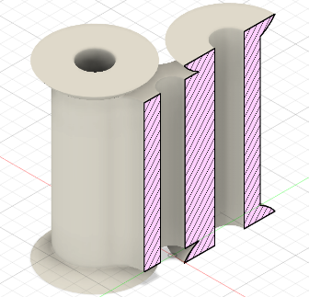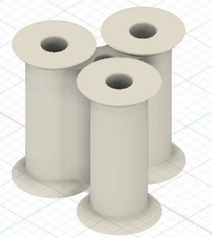

Figure - The spring used in the silicon parts

The first version used wooden sticks which have a diameter of 12mm and springs with a diameter of 14mm. The smaller circle at the bottom is used to secure the wooden stick while the outer ring is used to hold the spring. The cutouts are used to hold the M3 hex nut. There are a total of three cutouts located near the top of the bottom part. Respectively, there are three through holes on each part that matches up. They are the holes for the M3 screws. Screws are used in this mold to apply pressure to the seam to minimize the silicon from leaking. However, this proved to be unnecessary as the fit can be tight enough to contain the silicon when the right amount of tolerance is applied. There is a ring of silicon both on the bottom and the top of the mold. This is to make sure that the acrylic plates can secure the silicon in place without it detaching.

There are a few issues with this version. First, the use of the wooden stick meant that the size of the inner hole was unchangeable. This is especially problematic for experimenting with different wall thicknesses. Another issue was the sealed top plate. This meant the bubbles from the silicon cannot escape and would be trapped at the top making the surface uneven. The ring of silicon also was proven too small to keep the part in place. Applying a small amount of force will separate the plates and the silicon part. Due to the density of the stick, the inner surfaces of the silicon part were also not aligned properly.

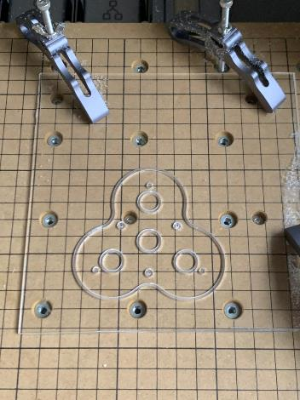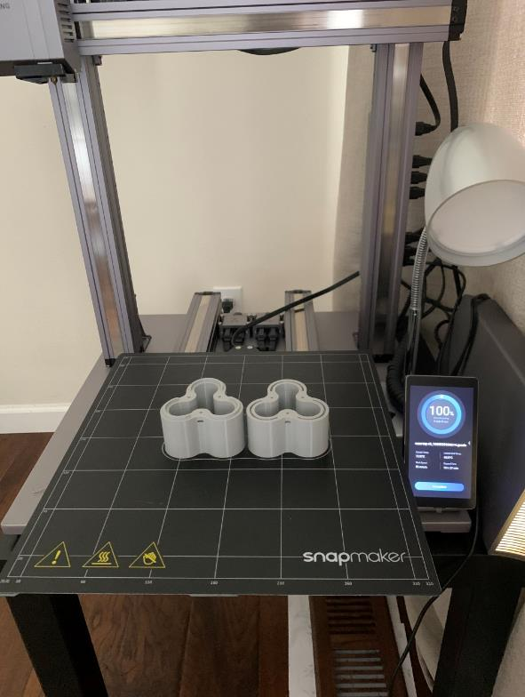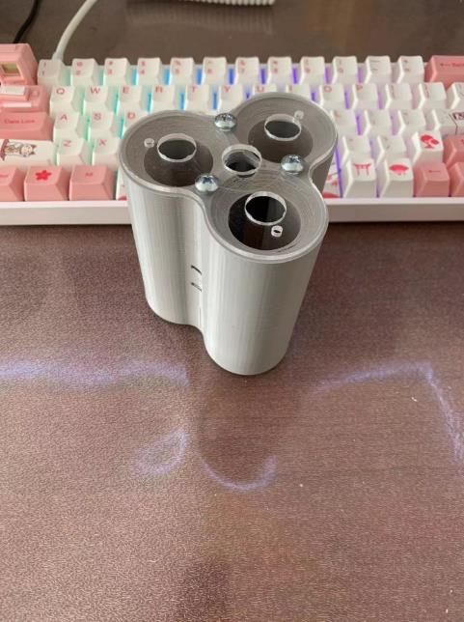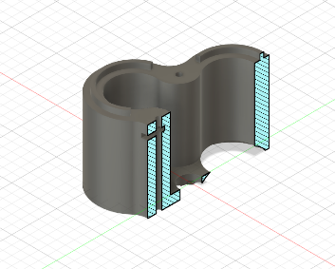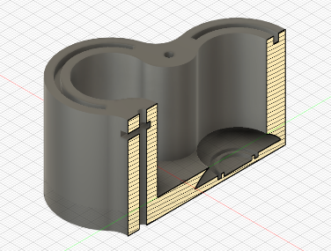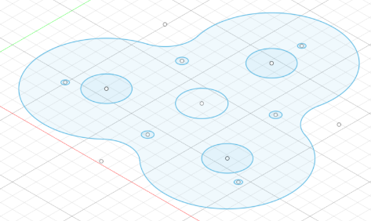

Figure - Version 1 of the mold. Top: CAD File of top, bottom, and plate, respectively. Cross Section Shown. Bottom: Top and Bottom, cover plate, and assembly

To test a variety of wall thicknesses, a new bottom with fixed pillars that is 14mm in diameter is designed. The ring was also enlarged to make ensure the part is secured. Since the stick no longer needs to be held in place by the plate and the bottom, The top was also removed to make sure no bubbles are formed. This new version had larger pillars but since it was fixed onto the mold, they had to be destroyed to extract the silicon body.

Figure - Version 2 of the mold. The stick is attached to the base, which made the removal of the mold from the silicon impossible

The third version redesigned the bottom so that the walls and the base detach. This means that the pillars and the base can be pulled out before removing the silicon body. Although the base was still difficult to remove, it can now be used multiple times. During the tests, it was also proven that the seal between the acrylic plates securing the silicon part and the silicon was too weak to withstand high pressures. Therefore, another silicon mold was added to create a thin layer of silicon that will be glued to the end to ensure an air-tight seal.

Figure - Left: Version 3 of the mold with a detachable base. Right: The new mold for sealing.

However, gluing two silicon parts together soon proved weak. It cannot contain the amount of pressure needed to move the snake. Therefore, a new mold is designed. This one allowed the silicon to be molded all at once and it only had one opening which is for the valve and the input for air. It flipped the orientation of the silicon part in the mold upside-down as now the only opening is now facing down. The pillars are now independent from the base and is secured by the hole in the bottom plate. The silicon part will be first removed from the mold A picture containing indoor, dark, light
with the pillars and then the pillars will be pulled out.

Figure - Left: Version 4 of the mold with a detachable pillar. Right: The assembled mold

Not only did the design of the mold change, but I also experimented with different wall thicknesses and inner diameters to find one that is most ideal for my use case. I used Simulia Abaqus to simulate the results to ensure that all variables are controlled, and only the independent variable changes.

The First experiment is to determine the best wall thickness. For this, I chose three different thicknesses, 4mm, 5mm, and 6mm with a uniform diameter of 15mm. I predicted that the thinner the wall is, the larger the angle gets, which matched the actual results from the simulation.

|  |  |  |  |  |
| --- | --- | --- | --- | --- |
| Wall Thickness (mm) | T1 Angle (°) | T2 Angle (°) | T3 Angle (°) | T4 Angle (°) |
| 4 | 22.5 | 32.07 | 41.36 | 42.7 |
| 5 | 18.96 | 29.8 | 34.22 | 36.98 |
| 6 | 4.96 | 19.85 | 24.18 | 29.9 |

Table - The angle of the silicon parts with various wall thicknesses at different times of simulation

|  |  |
| --- | --- |
| Wall Thickness (mm) | The angle at end of the simulation (largest angle) |
| 4 |  |
| 5 |  |
| 6 |  |

Table – The final angle after the silicon is fully inflated

Then, I tested the effect of inner diameter on the max angle the part can bend. I predicted that the angle is inversely proportional to the diameter as a larger diameter result in a larger surface area, and thus the pressure is more spread out and can deform the silicon less. Turns out the hypothesis was partially correct. While the 14mm starts with smaller angles, it has the largest angle.

|  |  |  |  |  |
| --- | --- | --- | --- | --- |
| Diameter (mm) | T1 Angle (°) | T2 Angle (°) | T3 Angle (°) | T4 Angle (°) |
| 14 | 10.55 | 23.43 | 33.64 | 38.88 |
| 15 | 18.96 | 29.8 | 34.22 | 36.98 |
| 16 | 21.42 | 29.31 | 34.24 | 34.93 |

Table - The angle of the silicon parts with various inner diameters at different times of simulation

|  |  |
| --- | --- |
| Diameter (mm) | Final angle |
| 14 |  |
| 15 |  |
| 16 |  |

Table – The maximum angle the silicon parts can reach. 14mm version has the largest angle

Although it was established that the segments are going to be designed with the idea of modularity, the actual approach changed. The first iteration was using ESP8266 as a microcontroller for each segment, and there will be one for each segment. They will be connected using I2C and instructions are going to be sent from the OpenMV module at the front. However, after some research and experiment, it was concluded that although labeled with such a feature, ESP8266 doesn’t support receiving I2C. Thus, the protocol was switched to Serial, which provides similar functionality but require me to program my own communication protocols.

# 结构设计

插图详细的说明本装置的结构特点，通过总分的方法，先介绍整体结构的特点、结构组成（xxx装置/机器由xxx模块、xxx结构组成）、而后详细的介绍每个模块的特点，介绍每一部分为什么要这么设计，优点在哪里等

As mentioned, the structure is designed intentionally to be modular, meaning that the length of the robot can be adjusted depending on the need. This also helps with maintenance as parts can be easily replaced. The front has an OpenMV module attached and then each segment follows is identical. Tubing for air runs along the snake and whether the chamber inflates or not is controlled by air valves placed at the entrance of the chamber. Each valve is controlled by the ESP8266 of that segment and the tubing is connected to a custom-printed valve core that ensures an air-tight seal between the tubing and the silicon chamber. The silicon body is connected using acrylic sheets pushed together. The chambers are placed in a triangular pattern with a hold in the middle for wires and tubing. This shape provides stability and functionality. The top has one chamber to push down the robot for better friction and contact while two chambers on the bottom control turning. The robot is propped on fixed rubber wheels to add friction and reduce wear on the acrylic and silicon parts.

# 硬件设计

详细说明本装置运用了哪些电子元件，这些电子元件的优点是什么，在本装置中的作用是什么，

The OpenMV at the front of the robot is used for image recognition as well as for sending signals to each segment and controlling the movement of the robot. It is programmed in micro-Python. This allows for simpler code as well as the possibility to add AI recognition through OpenCV to the robot. Each ESP8266 is a receiver for the commands and a controller of each air valve. ESP8266 can be coded in Arduino and is feature packed. The onboard Wi-Fi module allows the possibility to communicate via Wi-Fi with the other modules in the future.

# 运动模式（特点）/软件控制/程序设计

这一块重点说说自己这个装置的特点，能实现什么样的功能，（贴图说明）

比如变形式机器人，可以说明每个变形形态的特点，以及为什么设计这个变形形态。

多模式机器人：可以说明每个模式的特点，设计该模式的意义等，

多功能机器人：可以重点说明每个功能的运行状态，以及该功能的优点及必要性。

There are two movement types that the robot can perform depending on the environment and they all drew inspiration from the movements of a real snake. The serpentine locomotion is best for general purposes when there is a lot of open space. It is the S-shape movement people normally associate with snakes. The other type is concertina locomotion. This is best suited for tighter spaces where the snake cannot perform serpentine locomotion. It curls its tail while keeping the front stationery, and then keeps its tail stationary and extends its front. This repetition of curling and extending allows the snake to travel at narrow pathways. Each of these is achieved by predefined controls in the front OpenMV. There are two controls currently. The first is manual, where the user can directly control the movement of the snake. The second is automatic, where the snake will use its front-facing camera to follow a certain object. Regardless of which method, the openMV module converts the desired locomotion into a series of movements each segment performs and is distributed to each ESP8266. Since they relate to the same Serial port, a package header with an address that is unique to each segment is attached to the beginning of the command to assign this instruction to a specific segment.

|  |  |  |
| --- | --- | --- |
| Name | Purpose | Size |
| Header | Signals which segment this command is for | 1 byte |
| Instruction | A code represented in numbers tells the ESP8266 which action to perform. | 1 byte |

Table – Structure of the packages send out by the OpenMV to each ESP8266

# 总结与展望

说说本项目的完成情况，因为我们最终做出的成品和最初的设计肯定是有出入的，说明制作完成的成品有哪些优点，有哪些需要改进的地方，

在未来的研究中，可以对该项目做如何的改进和优化等。

This project did not achieve everything planned at the beginning. It only achieved the basic function of the robot, yet it is lacking a lot of software to support it. The implementation of an AI image recognition system is crucial as well as a purely image-based mapping system is also yet to be done. A coordinate system is also necessary to know the actual location of the snake. Without these, the robot cannot achieve its full potential as a life-saving device. Apart from the software, the silicon body design will also need to be improved as the current design does not make use of the pull potential of the air pressure.

参考文献